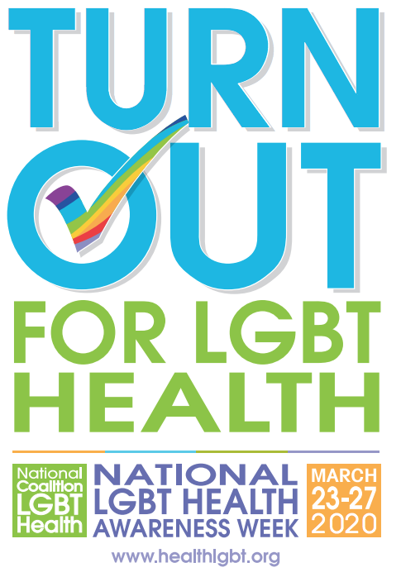

2020 Promotional Toolkit

Why the Theme?
This year’s theme was developed based on a survey of the Coalition's members showing the need for ongoing engagement of the LGBTQ+ community on healthcare issues. The theme motivates the LGBTQ+ community to “Turn OUT for LGBT Health” by advocating for LGBTQ+ health and mobilizing voter turnout in support of LGBTQ+ health equity.

Print
Click on the desired link to download official National LGBT Health Awareness Week posters for printing. Various sizes are available, including a sticker.

- Printing Materials
  - Poster (11 x 17) - Click Here
  - Poster (8.5 x 11) - Click Here
  - Poster (5.5 x 5.5) - Click Here
  - Sticker - Click Here

Images
Click on the desired link to download official National LGBT Health Awareness Week logos and images. These images have been individually formatted for the given social media platform.

- Twitter
  - Profile Image - Click Here
  - Profile Banner - Click Here
  - Posting Image - Click Here

- Facebook
  - Full Frame LGBT Logo - Click Here
  - Full Frame Check Mark - Click Here
  - Half Frame LGBT Awareness Week - Click Here
  - Profile Banner - Click Here
  - Posting Image (Check Mark) - Click Here
  - Posting Image (Logo) - Click Here

- Linkedin
  - Profile Banner - Click Here
  - Posting Image - Click Here

- Instagram
  - Posting Image - Click Here

- Snapchat
  - Posting Image - Click Here

This is the official logo for the 18th annual National LGBT Health Awareness Week. You can find links above to download this image.

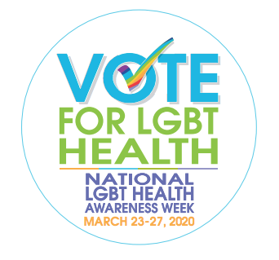
This image, based off the theme, can be used for printing stickers and buttons. You can find links above to download this image.

Follow Us and Share Our Postings
Facebook: @HealthLGBT
Twitter: @HealthLGBT
Linked-In: https://www.linkedin.com/company/national-coalition-for-lgbt-health/

Sample Postings
We have provided social media posts based on topics and timing, as follows. Please create additional postings based on your particular issue of concern.

Day of the Week | Postings | Hashtags
Monday (23) -  Advocacy | - As a community we must speak up and #TurnOUT for LGBT health policy #LGBTHealth @HealthLGBT  - Our community will #TurnOUT to ensure the rights for LGBT individuals. We demand equal protection #LGBTHealth @HealthLGBT  - Many LGBT people rely on copay assistance to afford their medications. #TurnOUT to contact your rep to ensure #CopaysCount #LGBTHealth @HealthLGBT  - Faith should not be above equality. #TurnOUT against religious exemptions #LGBTHealth @HealthLGBT  - LGBTQ+ Health communities have unique healthcare needs #LGBTHealth #TurnOUT @HealthLGBT  - The LGBTQ+ community must #TurnOUT to advocate for equitable, culturally competent care #LGBTHealth @HealthLGBT  - Ensure your voice is heard and #TurnOUT for #LGBTHealth @HealthLGBT | #TurnOUT  #LGBTHealth  #CopaysCount  #ACA
Tuesday (24) -  Voting | - 1 in 5 LGBT adults are not registered to vote. It’s time we change that. #TurnOUT to register and prepare to vote #LGBTHealth @HealthLGBT  - #TurnOUT for LGBT health through voting, advocacy, and education #LGBTHealth @HealthLGBT  - Ensure your voice is heard by voting this November #TurnOUT #LGBTHealth @HealthLGBT  - Your vote is a vehicle of change. Give power to your voice and #TurnOUT in support of LGBTQ+ health equity #LGBTQ+ @HealthLGBT | #TurnOUT  #LGBTHealth
Wednesday (25) -  Non-discrimination | - 18.4% of LGBT ppl avoid the doctor because of discrimination. #TurnOut and stop discrimination. #LGBTHealth @HealthLGBT  - Call State Reps with @OpenState and give your support for non-discrimination bills #TurnOUT #LGBTHealth @HealthLGBT  - LGBT discrimination is a human rights violation. Lend your voice and support against this discrimination and #TurnOUT for the LGBT rights. @HealthLGBT | #LGBTHealth  #TurnOUT  #StandOUT
Thursday (26) -  COVID-19 | - LGBTQ+ communities have higher rates of HIV and cancer (compromised immune system) = more susceptible to severe cases of COVID-19. Stop the spread and #TurnOUT for #LGBTHealth @HealthLGBT  - LGBTQ+ communities are less likely to seek healthcare because of descrimination. #COVID-19 #TurnOUT #LGBTHealth @HealthLGBT  - Check on #LGBTSeniors and provide support during #COVID-19 #TurnOUT #LGBTHealth @HealthLGBT  - Ensure LGBTQ+ communities are included in #COVID-19 outreach #TurnOUT #LGBTHealth @HealthLGBT  - Viruses don’t discriminate. #COVID-19 #TurnOUT #LGBTHealth @HealthLGBT | #COVID-19  #TurnOUT  #LGBTHealth  #LGBTSeniors
Friday (27) -  HIV and PrEP | - #TurnOUT for open dialogue. HIV-related stigma is not in our #2020Vision @HealthLGBT  - #Gay and #Bisexual men make up 70% of HIV diagnosis in the US #PrEP to #EndTheEpidemic #LGBTHealth #LGBTHealthCoaliton @HealthLGBT  - HIV education and awareness is vital to #EndTheEpidemic. Spread the word to save a life. #LGBTHealth @HealthLGBT  - 3 out 4 Black/African American #Gay and #Bisexual men who recieved an HIV diagnosis were between 13-34 #EndTheEpidemic #LGBTHealth @HealthLGBT  - Do you know about PrEP? Taken daily, PrEP reduces the risk of HIV by over 99%. Talk to your doctor about PrEP #TurnOUT #LGBTHealth @HealthLGBT | #TurnOUT  #2020Vision  #Gay  #Bisexual  #PrEP  #EndTheEpidemic  #HIV  #LGBTHealth
Saturday (28) -  Trans Health | - 1 in 4 trans ppl avoid doctors because of discrimination and mistreatment #TurnOUT #LGBTHealth #LGBTHealthCoalition @HealthLGBT  - Transgender individuals experience numerous barriers to healthcare due to lack of insurance and under-trained healthcare providers #LGBTHealth #TurnOUT @HealthLGBT  - Black transgender women make up 51% of HIV diagnosis #LGBTHealth #TurnOUT #LGBTHealthCoalition @HealthLGBT  - Black transgender men make up 58% of HIV diagnosis #LGBTHealth #TurnOUT #LGBTHealthCoalition @HealthLGBT | #TurnOUT  #LGBTHealth  #ACA  #StandWithPP
Sunday (29) -  LGBT Seniors | - #LGBTSeniors face barriers to health due to isolation and lack of social services #LGBTHealth #TurnOUT #LGBTHealthCoalition @HealthLGBT  - Studies show that LGBT seniors often feel the need to stay in the closet in the hopes of receiving the services they need. #OUTOppression #LGBTHealth @HealthLGBT  - 66% of #LGBTSeniors have experienced discrimination at least three times in their lives. #TurnOUT for #LGBTSeniors #LGBTHealth @HealthLGBT  - 34% of #LGBTSeniors fear having to re-closet themselves when seeking senior housing #TurnOUT for #LGBTSeniors #LGBTHealth @HealthLGBT  - Nearly 60% of #LGBTSeniors report feeling a lack of companionship; more than 50% reported feeling isolated from others. #TurnOUT for #LGBTSeniors @HealthLGBT | #TurnOUT  #LGBTHealth  #SAGETable  #LGBTSeniors  #LGBTHealthCoalition

